# Kubernetes Notes

* Kubernetes is a container orchestration tool
* A group of nodes form a cluster
* Kubernetes runs on containers in groups called pods
* Kubernetes **services** expose Pods to the Cluster and to the Internet
* Kubernetes Deployments control rollout and rollback of Pods.

Interacting with Kubernetes:

Rest API

Client Libraries

KubeCTL

## Pods

Basic Building blocks of Kubernetes

One or more containers in a pod

Pod containers all share a container network

Each pod gets an ip address (only one IP per pod)

Pods can communicate with one another by default

General Rule of thumb is to run a single container inside a pod.

## Labels

### Defining labels

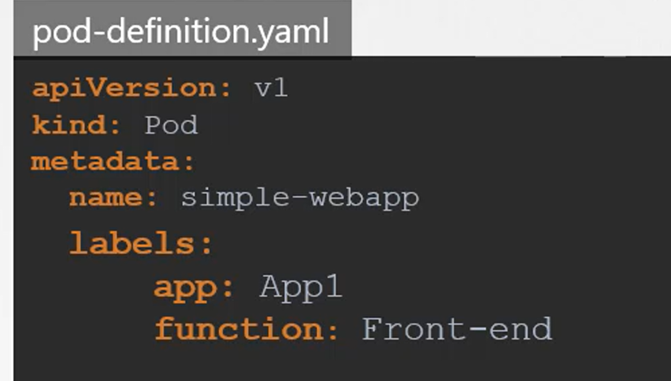

### Selecting by Label

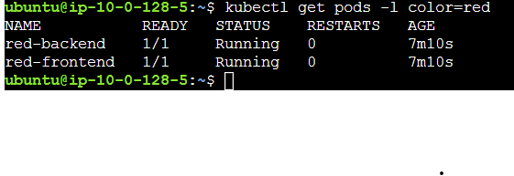

### Applying filters

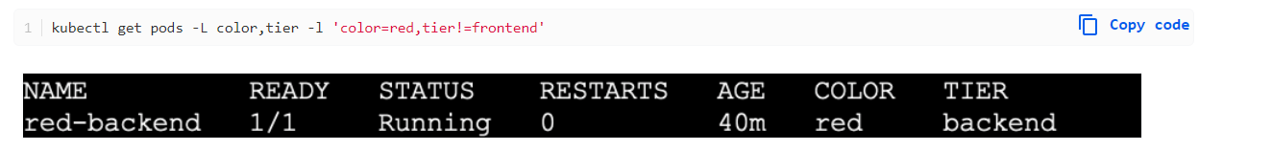

### Using selector

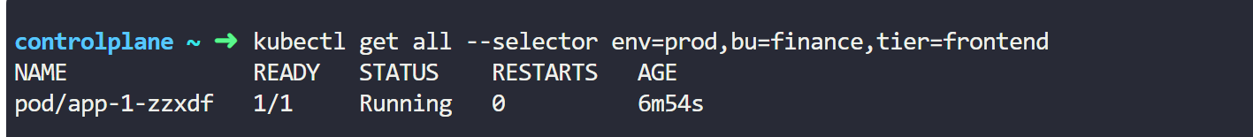

Note using the 'all' keyword will get all the selectors: replica sets and containers.

### Select and Count rows



You can define labels in multiple places.. they impact based on location:

* replica set (defined at top)
* container (defined in container)
* service (defined in service)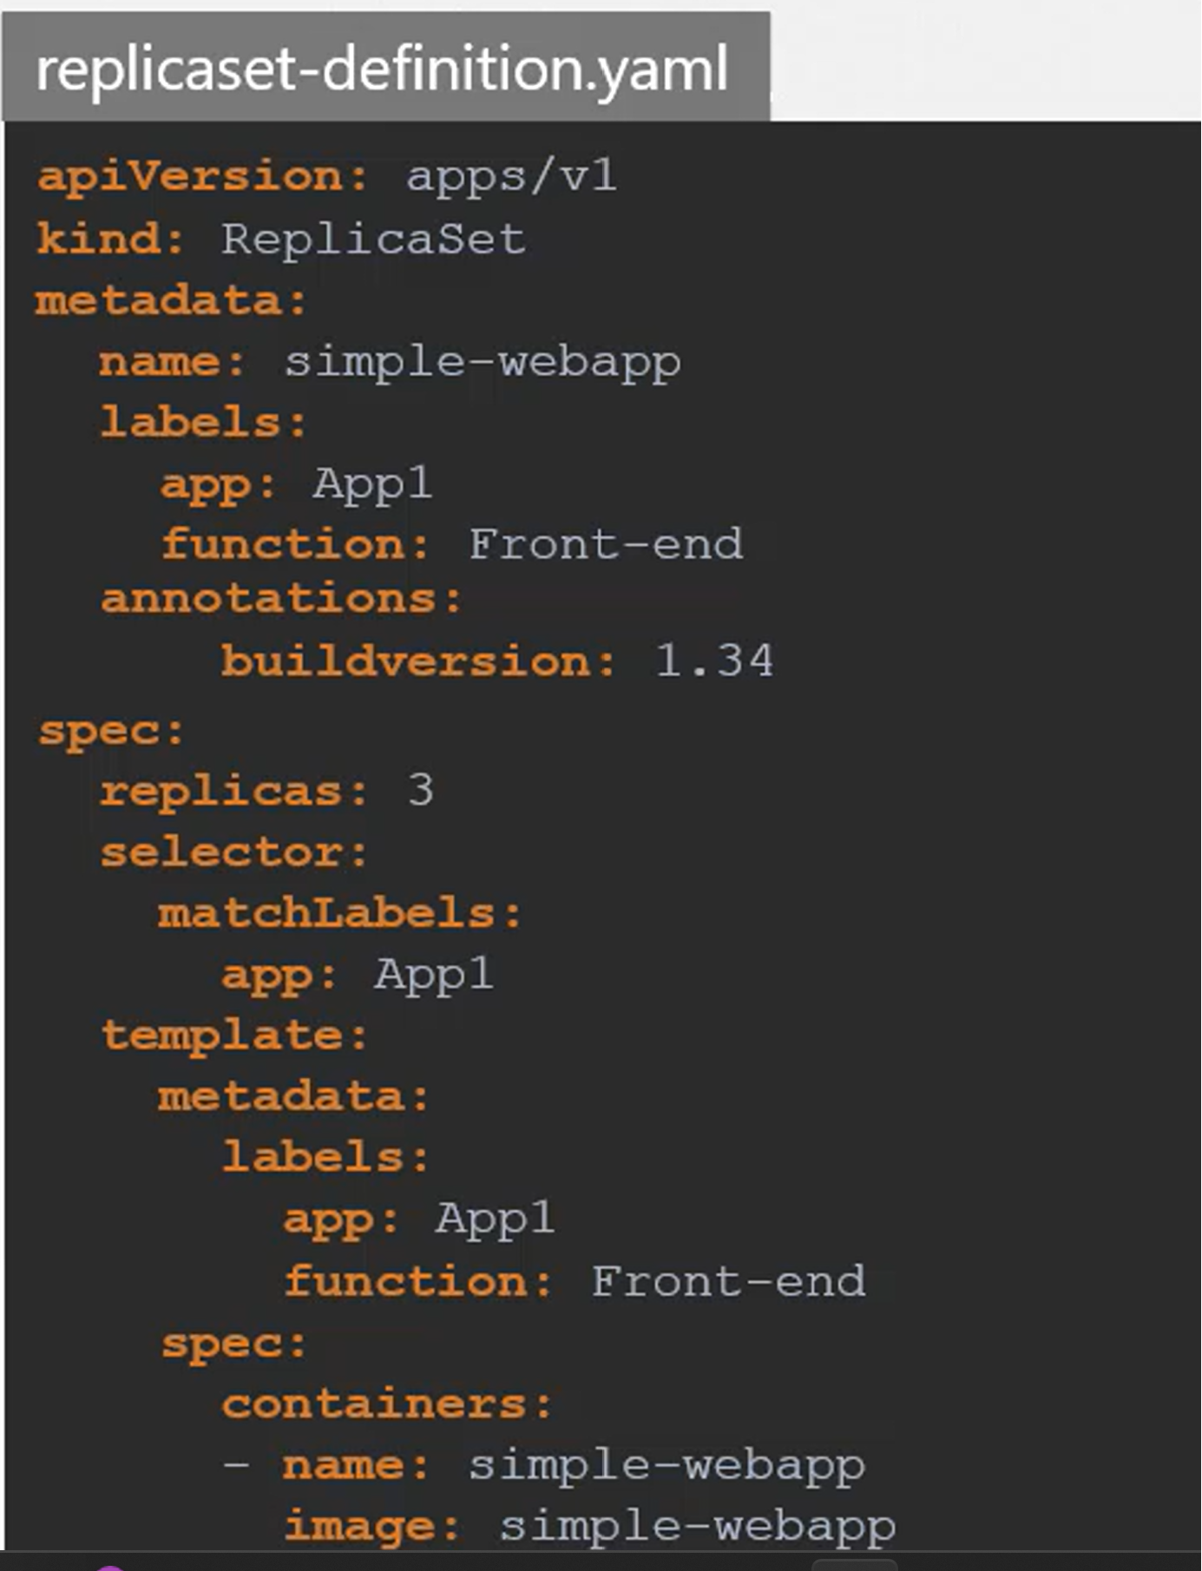

## Services

Define networking rules for accessing pods in the cluster and from the internet

Use labels to select a group of pods

Service has a fixed IP address

Services distribute requests across Pods to in the group to ease the load

Pods get their own service, and the lifetime of service is not tied to the pod.

Using the **selector** keyword in the yaml defines an item in the ‘spec’ section to belong to that label. Example:

| ------ apiVersion: v1 kind: Service Metadata:   Labels:  App: webserver  Name: webserver   Spec:  Ports: Port: 80 |
| --- |

**Selector:**

**We use the selector tag to target all pods that have the provided label. In this case the label is ‘webserver’.**

| selector:  app: webserver   App: webserver  Type: NodePort  ---- |
| --- |

## Namespaces

### Purpose of namespace

Separate resources according to the users, environments, or applications

Role-based access control (RBAC) to secure access per Namespace

Using namespaces is a best practice

Can also use namespaces to group together your separate applications environments.

For example use a database namespace and a webserver namespace.

* For this scenario, you’ll need a config map in each namespace.
* Same for secrets
* Services are sharable though using name format: resource.namespace
* Volume and node are not creatable/boundable to namespaces
* Can find all namespaced resources with:
  + Kubectl api-resources –namespaced=false

Can also use namespaces for a blue/green deployment, where one is live in production, and another is getting ready for production.

When defining a container in the yml file, be sure to provide a specific container tag or if using a ‘latest’ reference, give image pull policy of “ifNotPresent”

Example:

……

| Spec:  Containers:  -name: redis  Image: redis:latest  imagePullPolicy: IfNotPresent ..... |
| --- |

Note: All the containers have the same localhost dns value, because they share the same IP address. So you can reference other containers with <http://localhost>

### Accessing a resource outside a namespace:

[service name ][namespace][service][domain]

Example: db-service.dev.svc.cluster.local

* Service name: db-service
* Namespace: dev
* Service: svc
* Domain: cluster.local

Helpful commands:

* Kubectl get namespaces
* Kubectl config set-context $(kubectl config current-context) -namespace=targetNamespace
* Kubectl get pods –all-namespaces

Create a resource quota:

| apiVersion: v1 kind: ResourceQuota metadata:   name: compute-quota  namespace: dev spec:  hard:  pods: "10"  requests.cpu: "4"  requests.memory: 5Gi  limits.cpu: "10"  limits.memory: 10Gi |
| --- |
| kubectl create -f compute-quota.yaml |

### Setting to a target context

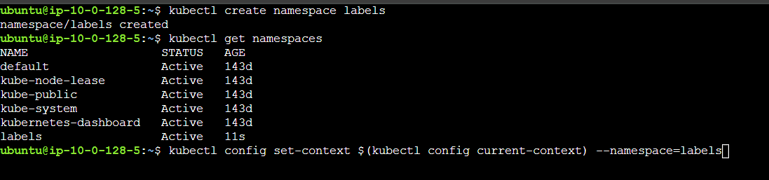

## Service Discovery

Why Services?

* Supports multi-pod design
* Provides static endpoint for each tier
* Handles Pod IP changes
* Load Balancing

What does manifest do?

Kubectl create will send manifest to the Kubernetes API

API Server will then do the following:

* Select Node with sufficient resources
* Schedule Pod onto the node
* Node will then pull the Pod’s container image
* Node will then start the Pod’s container

## Multi Container Pods

Containers running in the same pod act like a docker-compose deployment. Where each container can talk to the other on the same shared network, thus they reach one another via using the localhost as the address , plus the port.

### Ambassador

Creating a container that will automatically connect to a service based on the environment .

For example connecting to Dev, Test, Prod databases based on the environment. That way you can develop your code to connect to a database at 'localhost' and it always connects to the right service.

### Adapter

### Sidecar

## Master vs Worker

Your master nodes are most important but take less resources due to less load.

You can add more masters or workers easily.

Deployment vs service (each one has its one attributes

## Helm Charts

Helm chart is a packaged configuration for multiple services. It uses template files which utilize place holder values. Such as {{ .Values.name}}

Where Values here references a yaml file named “Values.yaml”

Uses directory structure:

| Mychart /   Chart.yaml  Values.yaml  charts/  Templates  ... |
| --- |

* Mychart is the name of the chart
* Chart.yaml has the meta info for the chart
* Values.yaml has the values for the template files
* Charts folder has all the chart dependencies
* Templates folder has the actual template files

## Volumes

Persistent Volume

Persistent Volume Claim

Storage Class

Storage Requirements are

* Storage that doesn’t depend on the pod lifecycle
* Storage must be available on all the nodes
* Storage needs to survive even if the cluster crashes.
* Therefore should always use remote storage

## Stateful Set

What is a stateful application?

* Not ideal for containerization
* Old databases
* Track state in records
* The application pod gets a unique identifier
  + Using the same specification as replicas but not the same identifier.
  + Pods are not interchangeable.
  + Only one pod can be used to write data, but other pods can save a copy.
    - 1 master pod
    - Then slave pods
    - Slave pods do not have access to the same storage , each has its own replica.
    - Slaves have to continuously synchronize.
    - Best practice is to use data persistence with database. So that even if all the pods die, the Persistent storage will still be there

What is a stateless application?

* Doesn’t depend on previous data
* Acts on the fly
* Great for containerization

## Probes

* Used to check specific attributes for a pod or container application.

## Init Containers

* Run before your applications begin. Special container meant to run before the main application starts.
* Can have multiple init containers
* Can have utilities helpful for configuring but left out of actual application
* Help prevent application from launching if certain conditions don’t meet
* Run each time an application runs. Always assumes the init container runs at least once.
* CANNOT add readiness probes to init containers
* Multiple init containers will run **SEQUENTIALLY**.
* If any of the init containers fails, the **POD RESTART**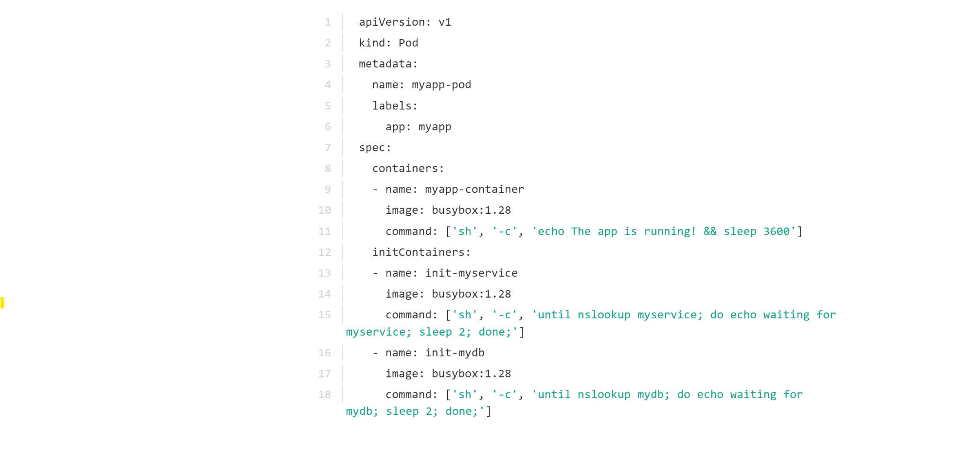

## Readiness Probes

Used to check if a pod application is ready.

Put the following options in the containers section.

|  | You can use the following options to delay, ping, or increase attempts to probe: |
| --- | --- |
| Liveliness Probes work similarly, as they are used to check if a container is still running or if the application is meeting a certain condition. |  |

## Volumes

* Pods can use 1 more volumes
* Volumes are tied to a pod

## Dockerfile vs deployments

### Commands in Dockerfile

* Docker uses the ENTRYPOINT command to specify the command code or command you wish to call and append to with default values or provided arguments
* Example:

| from ubuntu ENTRYPOINT [“/opt/usr/”, “airflow”]  CMD [“scheduler”] |
| --- |

* CMD provides a default value , otherwise when you run the image, you can specify an argument:

| Docker run my-image init-db |
| --- |

* “Init-db” will be ran instead of the “scheduler”. So the full command will be ran inside the container:
* /opt/usr/airflow init-db

### Commands in kubernetes:

* Use “command” to specify the entrypoint.
* Use “args” to specify the cmd

| apiVersion: v1 kind: Pod metadata:  name: ubuntu-sleeper-pod spec:   containers:  - name: ubuntu-sleeper  image: ubuntu-sleeper  command: ["sleep"]  args:["10"] |
| --- |

## Kubectl Explain Command

In order to learn more about a resource inside yaml file, you can specify it via the kubeclt explain:

| kubectl explain Pod.spec  Or..  kubectl explain Pod.spec.containers.image |
| --- |

## Config Maps

* Used to store variable settings/default values in a single location
* Uses key/value pair format
* 1st create the config map, 2nd inject it into the pod.

### How to create config map imperatively:

| kubectl create configmap <config-name> --from-literal=<key>=<value>  kubectl create sample config-name --from-literal=age=25 --from-literal=name=gaelan |
| --- |

### How to create config map from file:

| kubectl create configmap <config-name> -from-file=<path-to-file> kubectl create configmap app-config -from-file=app_config.properties |
| --- |

Format for configmap file is:

| apiVersion: v1 kind: ConfigMap metadata:  name: app-config data:  APP_COLOR: blue  APP_MODE: prod |
| --- |
|  |

### How to add your config map to the pod.

| apiVersion: 1  kind: Pod  metadata:  name: simple-webapp-color  labels:  name: simple-webapp-color  spec:  containers:  - name: simple-webapp-color  image: simple-webapp-color  ports:  - containerPort: 8080  envFrom:  - configMapRef:  name: app-config |
| --- |
| config-map.yaml ->  apiVersion: v1  kind: ConfigMap  metadata:  name: app-config  data:  APP_COLOR: blue  APP_MODE: prod |

Other examples  
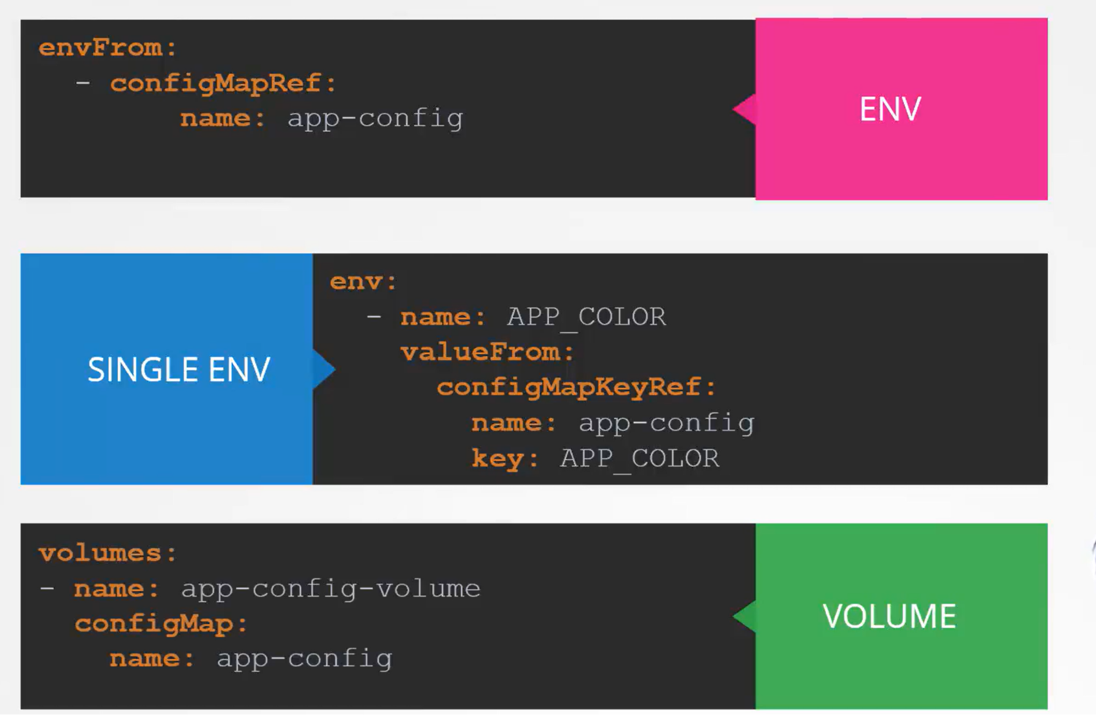

## Secrets -

* Secrets are available to whomever has access to the target namespace
* Best practice is applying encryption at rest - <https://kubernetes.io/docs/tasks/administer-cluster/encrypt-data/>

### Imperative Method:

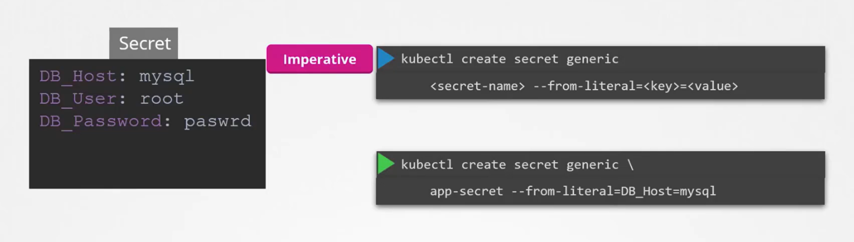

### Declarative Method

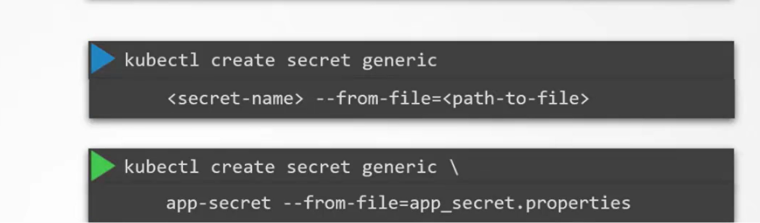

### kubectl create -f method

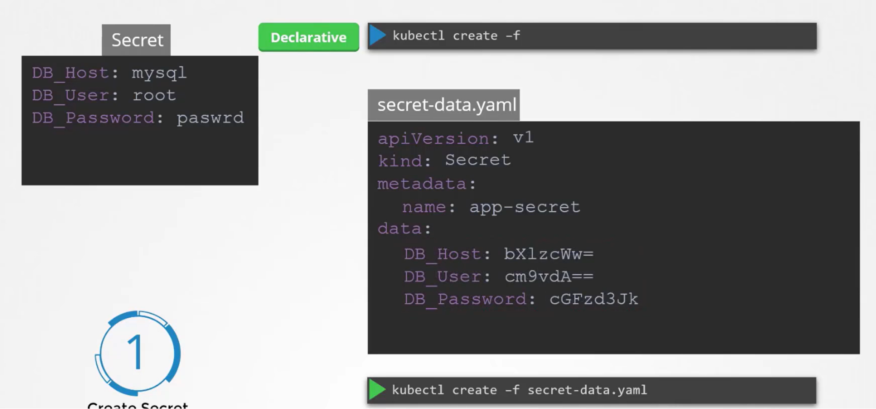

### Accessing secret in Pod:

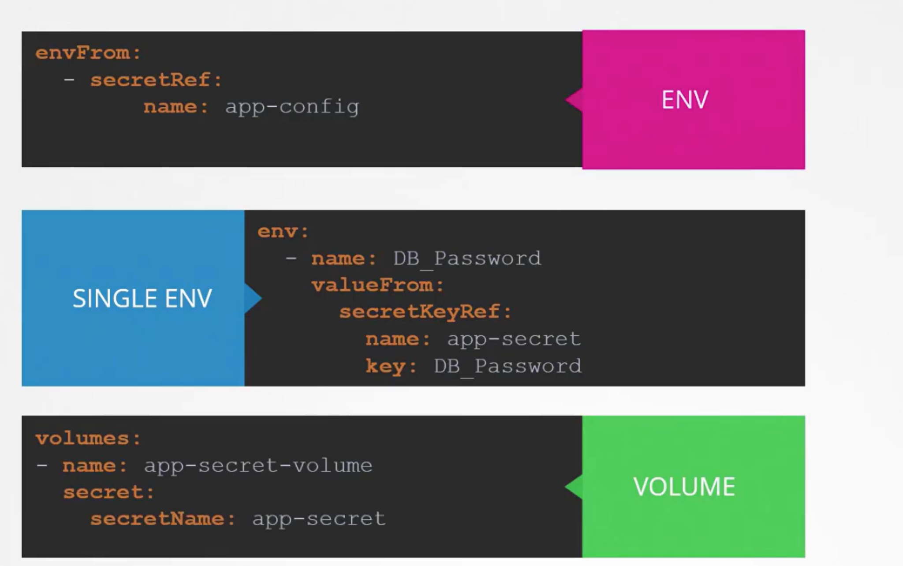

## Docker Security

### Namespace inside a namespace

* Docker containers will run inside their own namespace, this namespace will be ran inside the namespace of the kubernetes context.

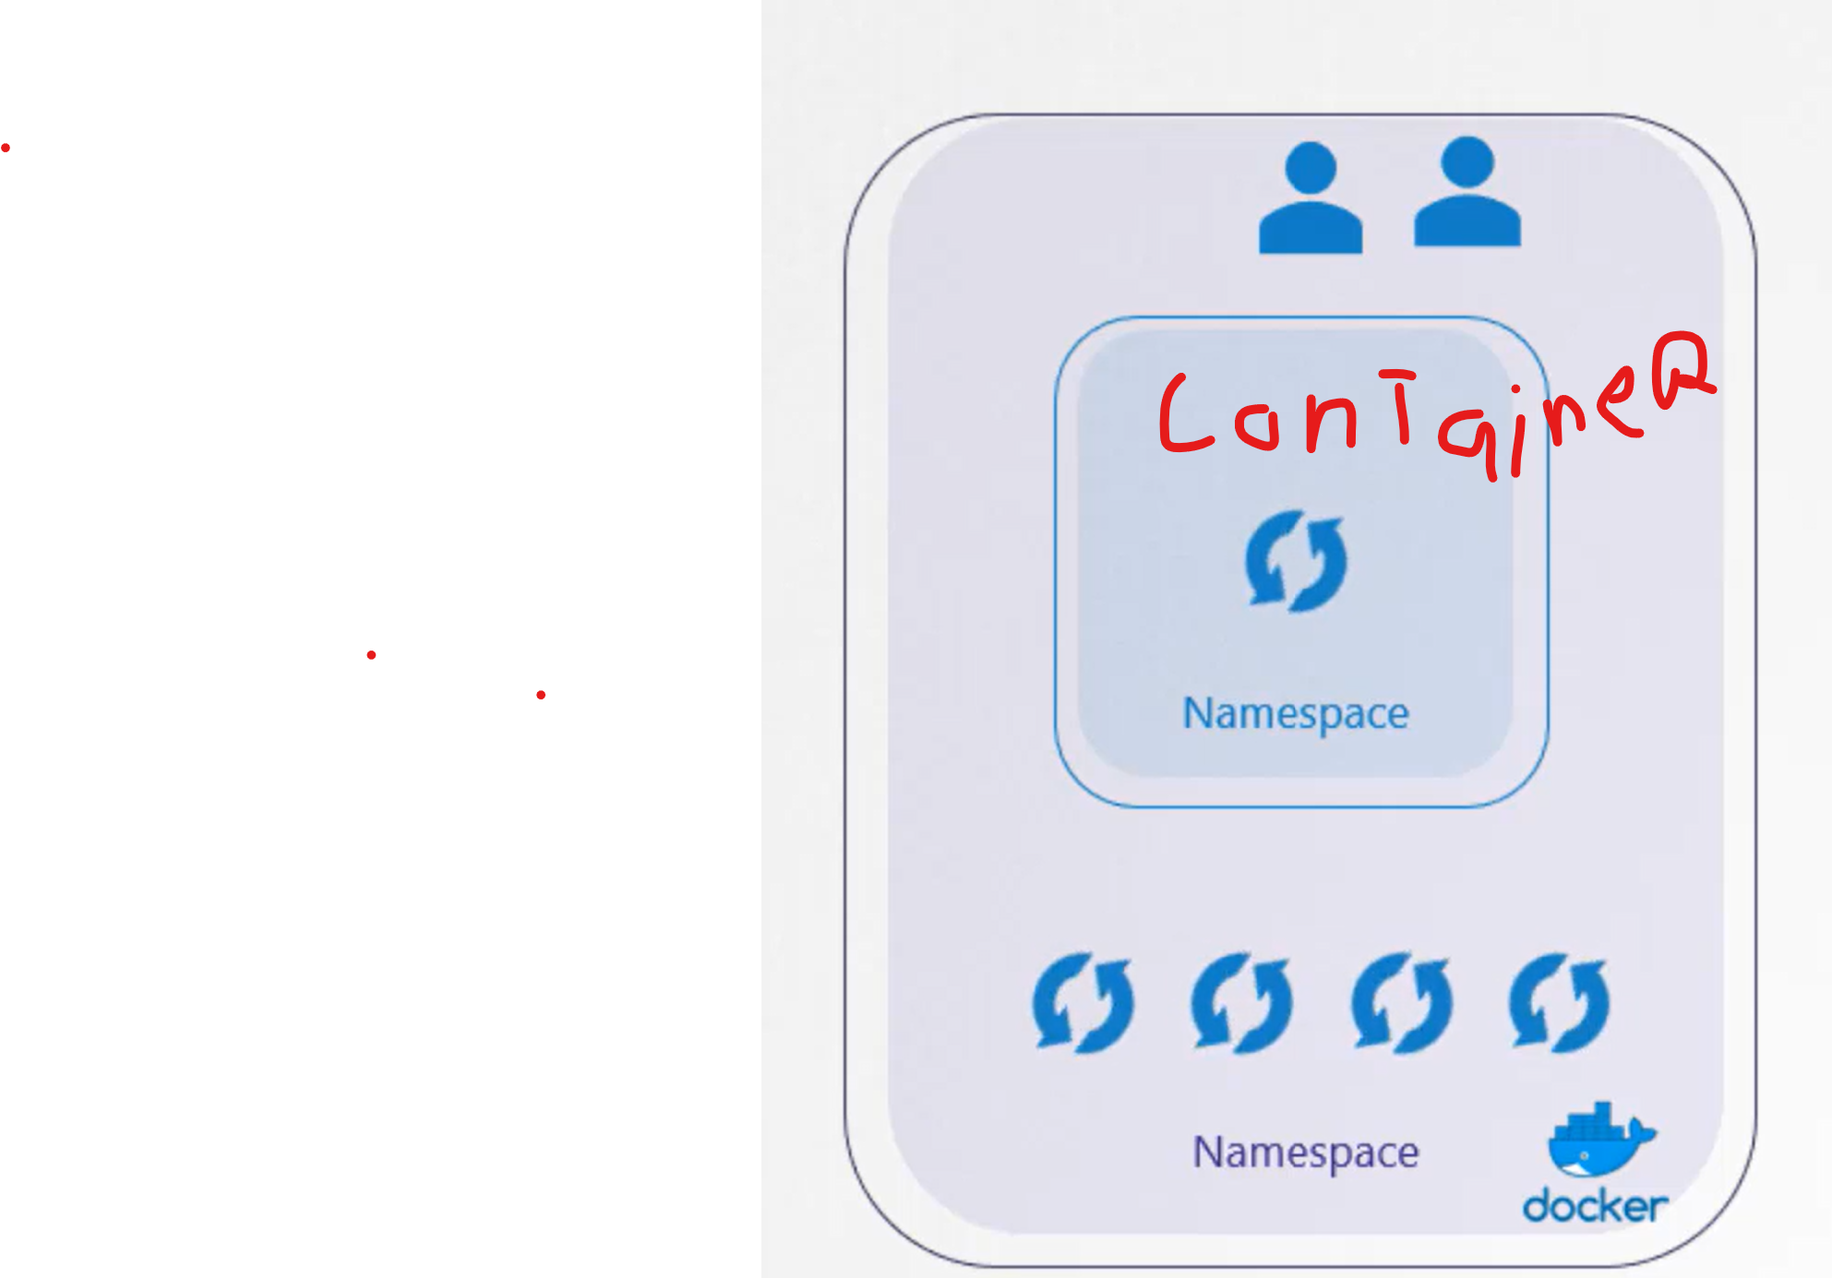

* Root in container is not same root as in host

### Limited privileges

* By default docker runs containers with limited privileges.
* The following privileges are available to be enabled:

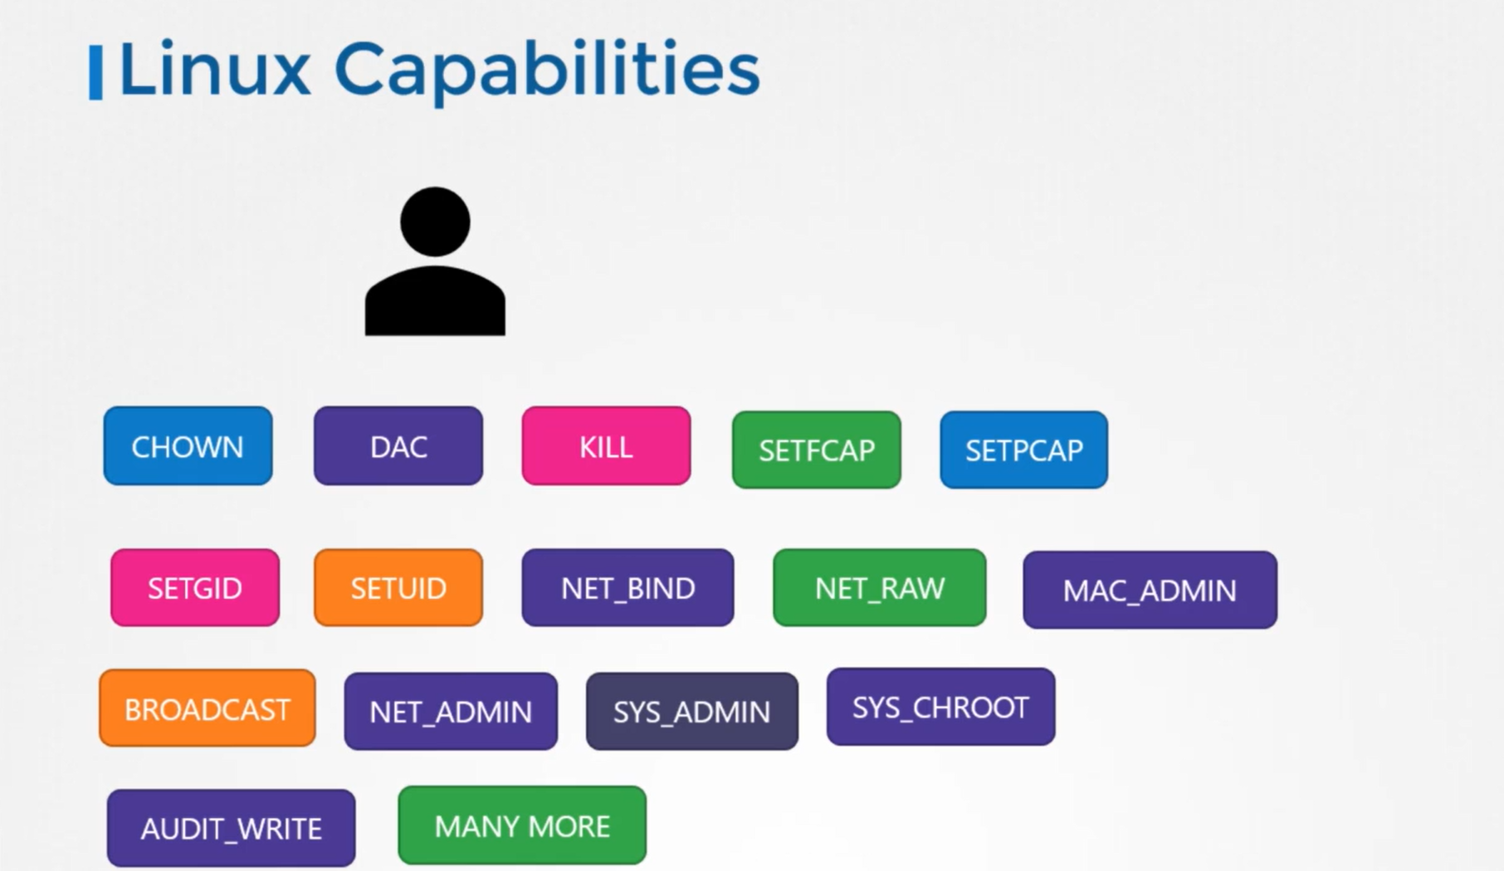

### Running adding/removing privileges

* You can add privileges with –cap-add command:
* 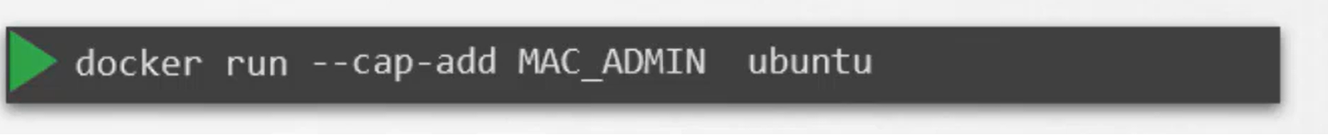
* To run with less privileges you can use –cap-drop command:
* 
* To run with all privileges you can use –privileged:
* 

## Security Contexts

The Docker layout above can be translated to Kubernetes.

You can configure security at the following levels

* container level
  + Supports adding capabilities
* pod level
  + No support for adding capabilities
* both container and pod level
* Note: Container config will override pod config.

### Pod level

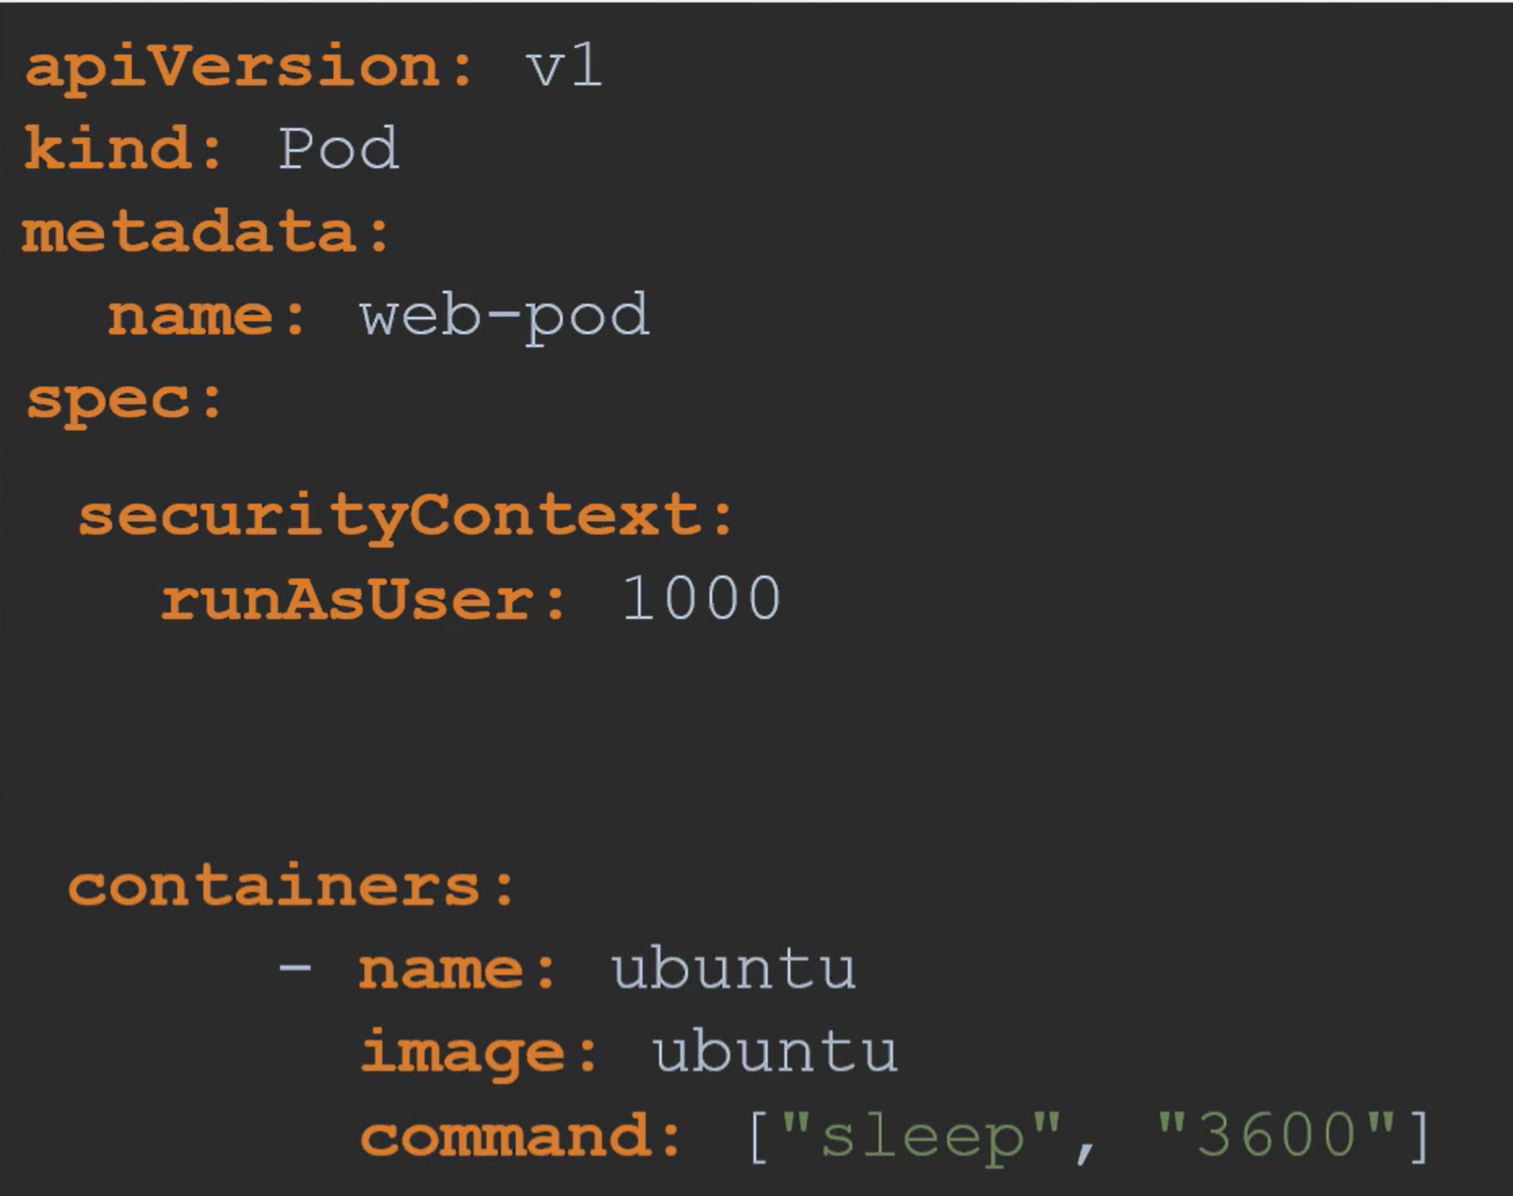

### Container level

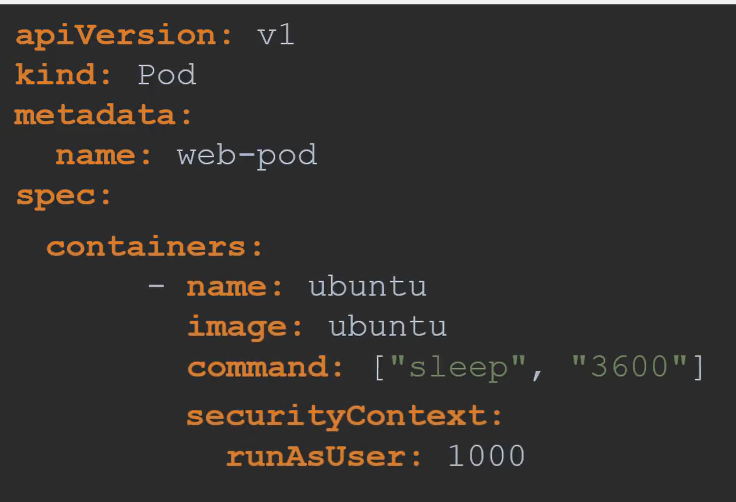

* To add capabilities:
* 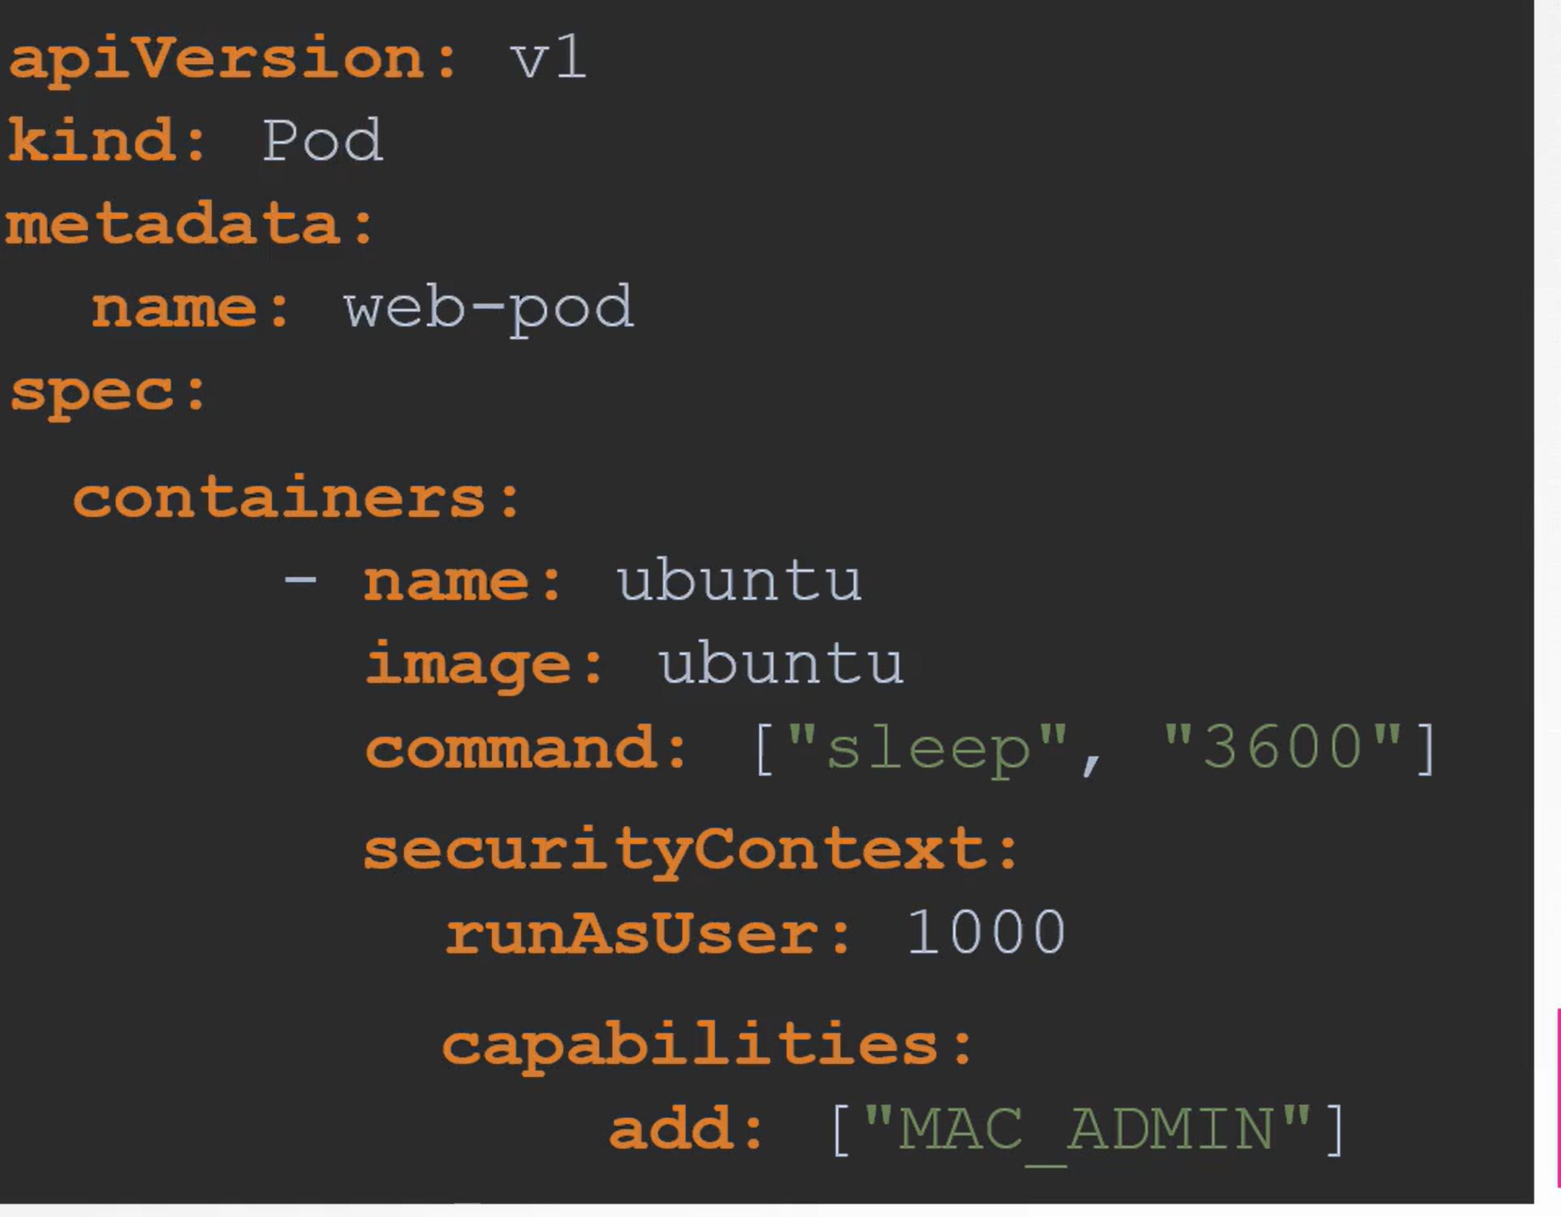

## Service Accounts

### How to create/view service accounts

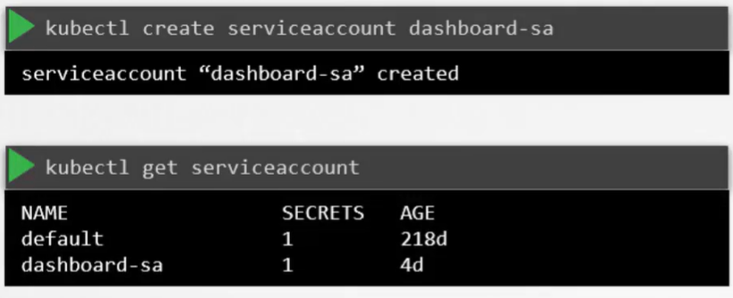

New service account has a token. Token has to be used to interact with the service account from outside the network. The token is saved to a secret and is encrypted. The token can be used to interact with the Kubernetes API.

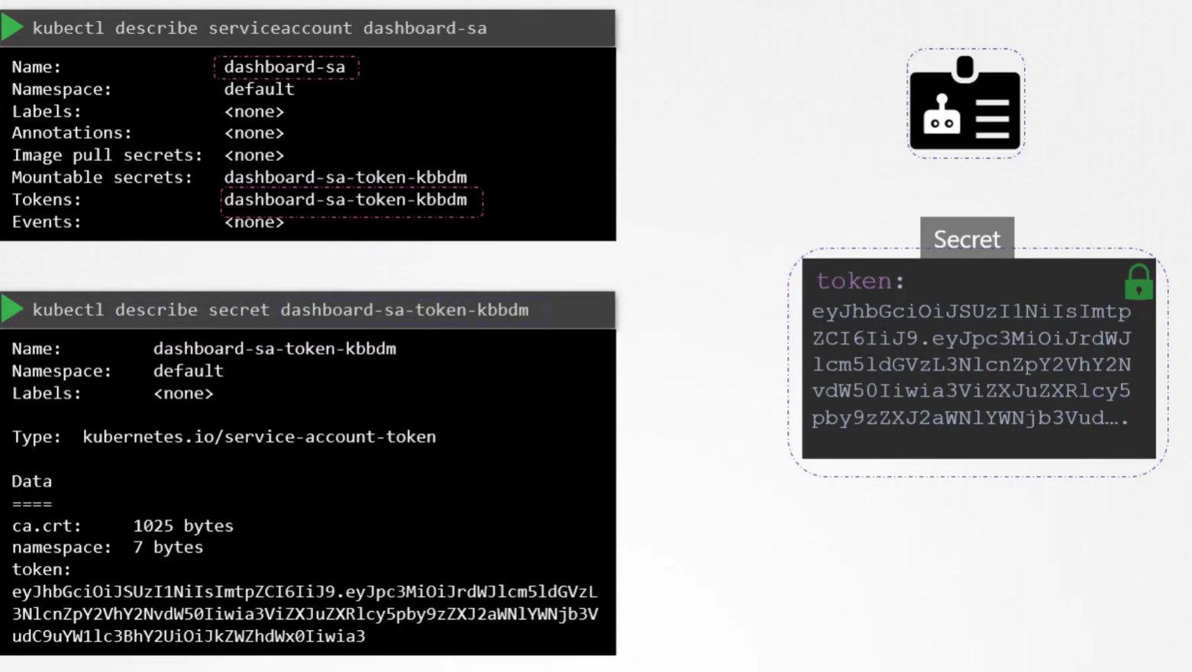

Note: There is always a default service account created in a namespace

### Mounting secrets location as a volume

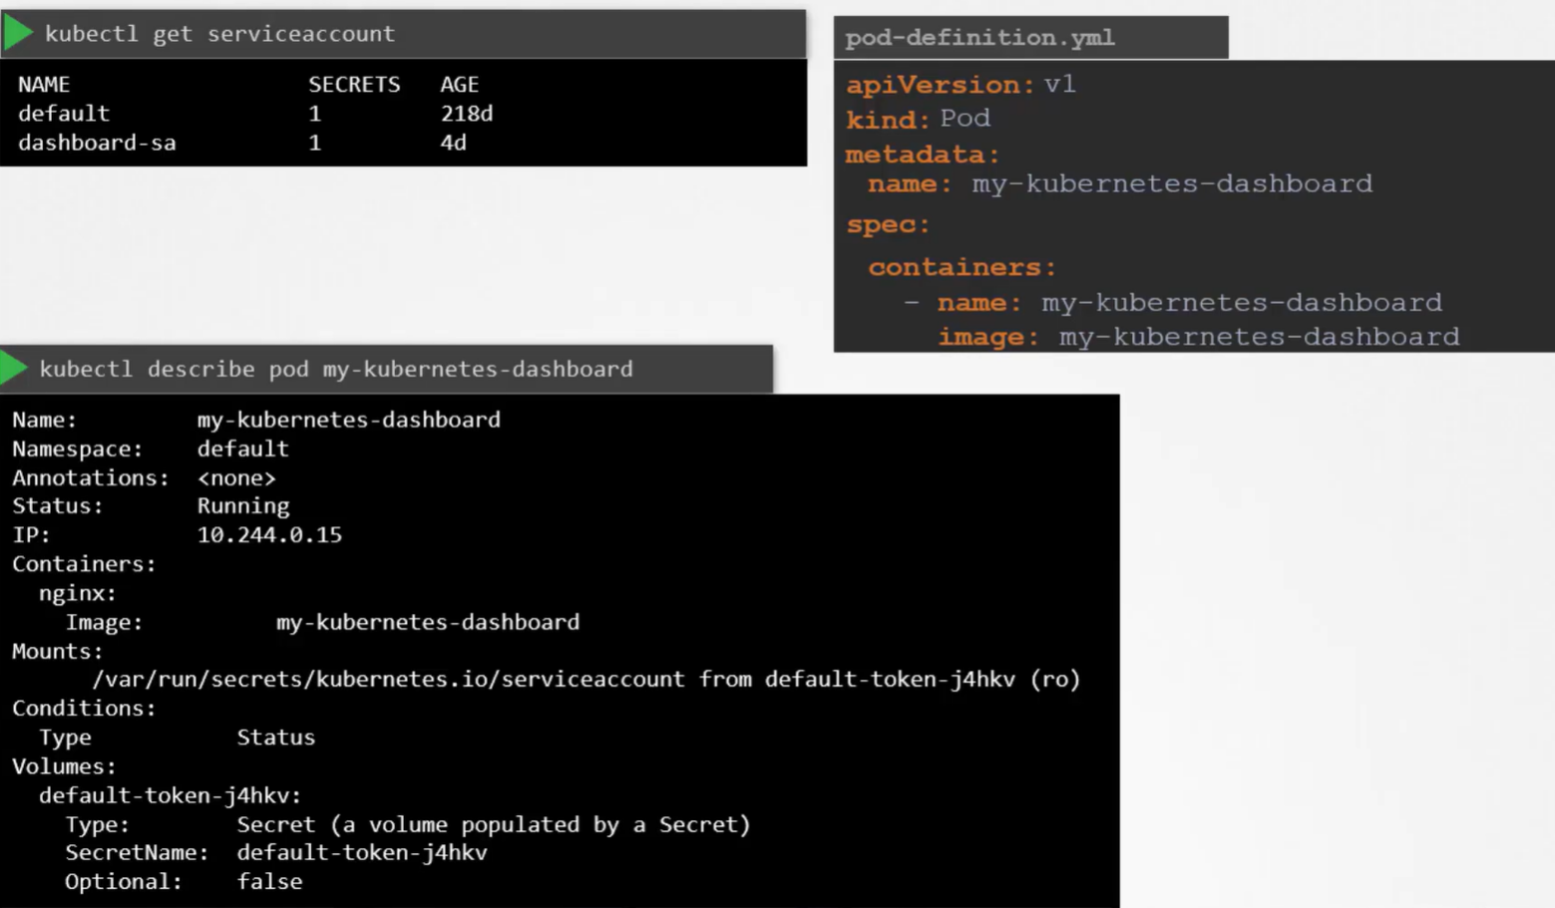

Note: Kubernetes will automatically mount service account token unless you define otherwise:

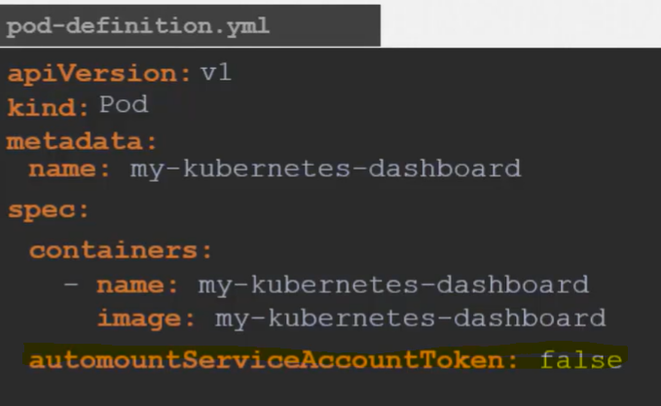

### Reduction of Secrets v1.2:

You will need to run the kubectl create token <serviceaccountname> to generate a token

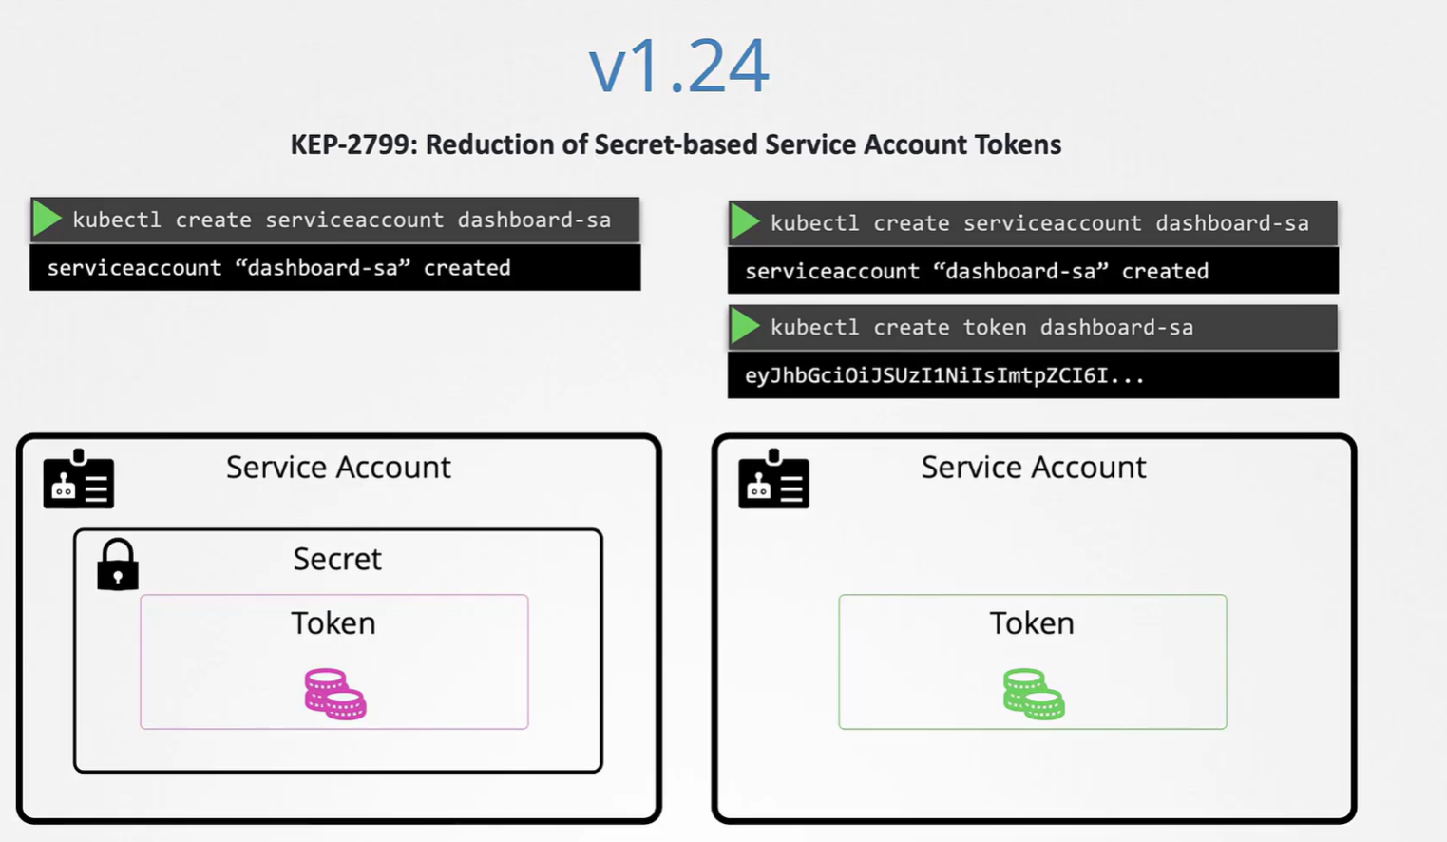

### Decoding a token



## Resource Limits

### How to find cause of the crash. Use 'watch kubectl get pods'.

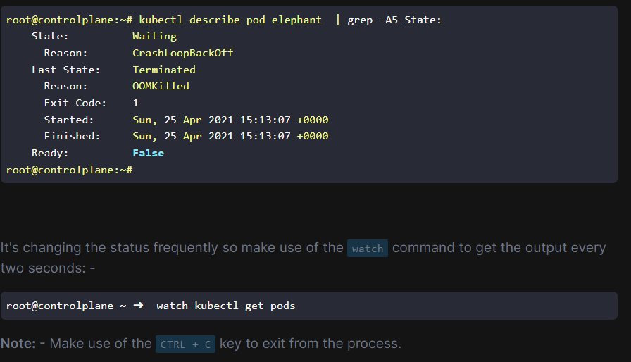

## Taints and Tolerations

Used to set what is tolerable on a node. Kubernetes scheduler tries to schedule pods on nodes,

based on limitations that are defined.

You can define a taint on a node, preventing pods from being assigned to a node.

You can then define tolerations on a pod to make it tolerant to the node. Taints will cause a pod to be scheduled to any node that doesn't have a repellant that node can't tolerate.

Note: Master Nodes get taints right away. You can see this with command:

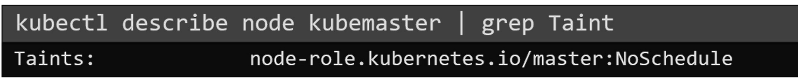

### Create a taint

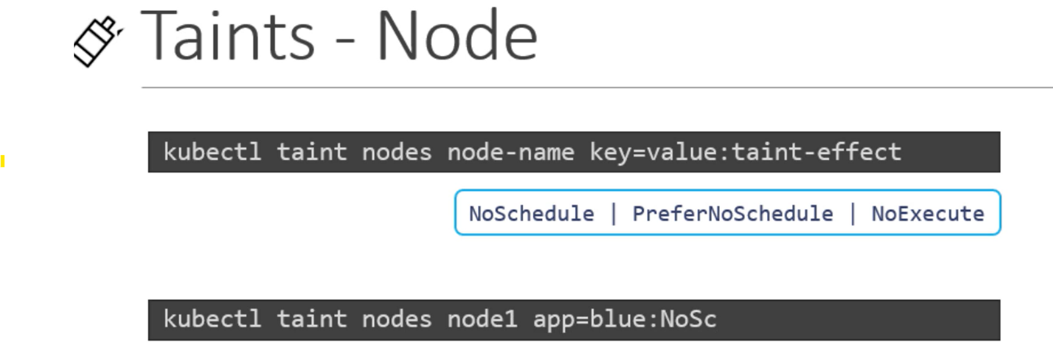

### Create a toleration

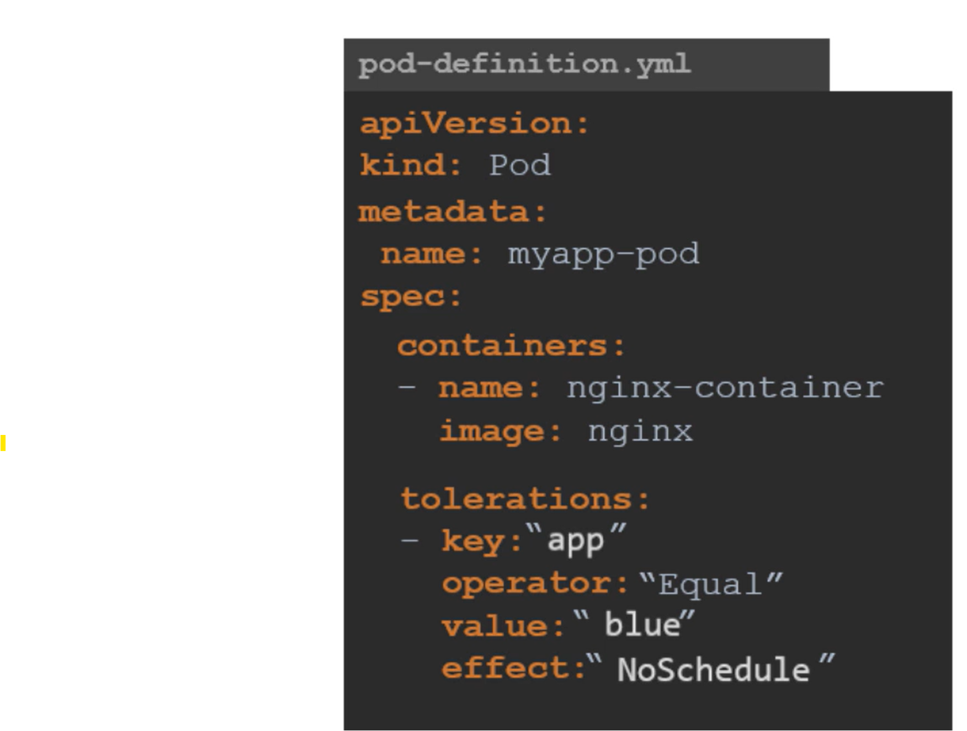

### 

## Node Selectors

In order to use a node selector, the node you want to select needs to have a **label**.

* Define the label
* Define the node selector

### Labeling a Node

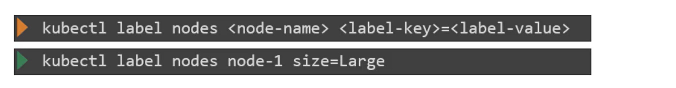

### Define a Selector

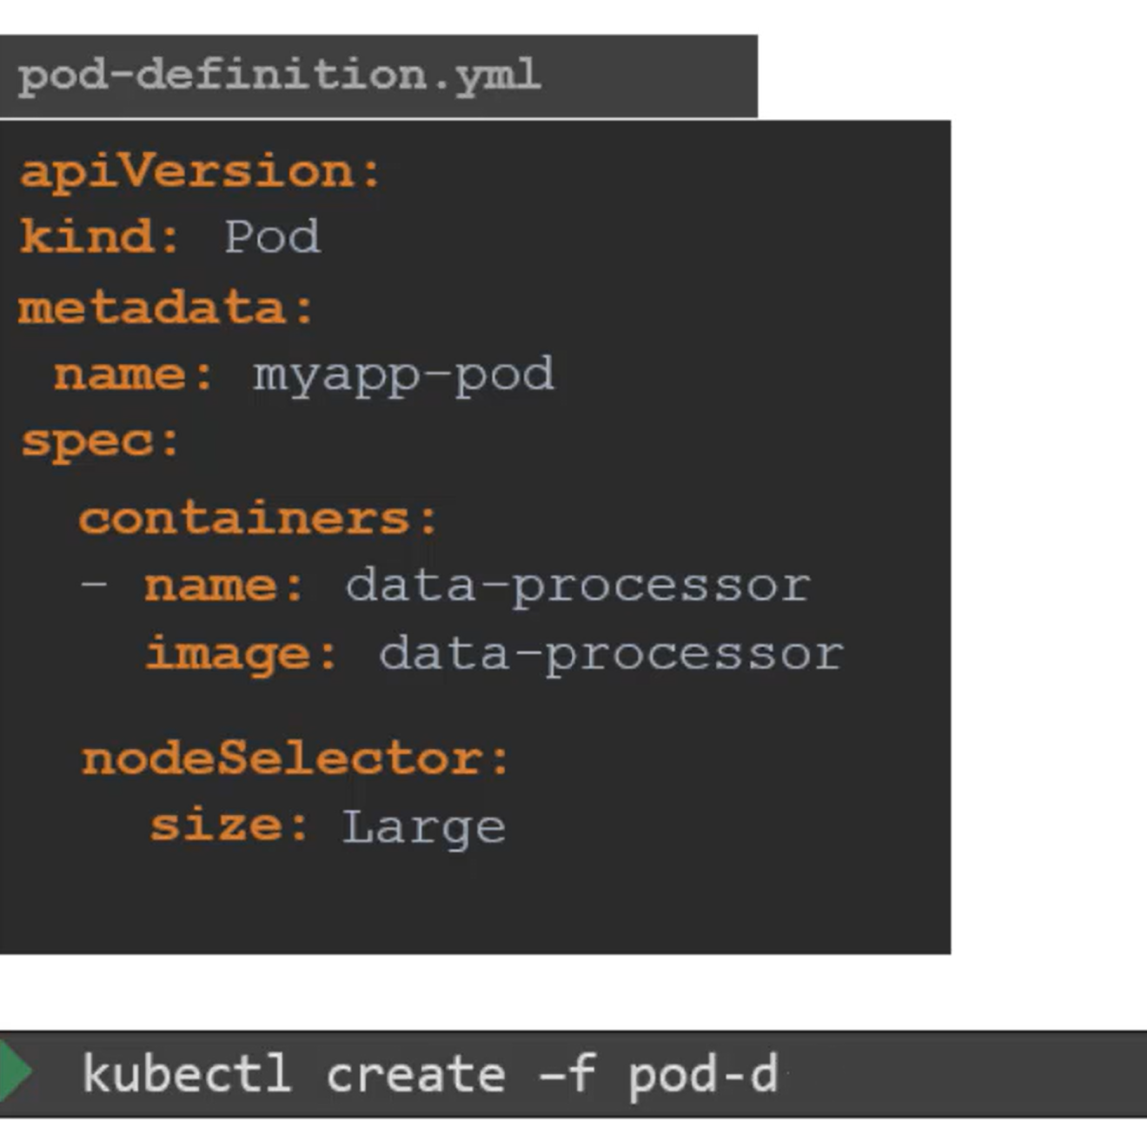

## Node Affinity

Provides ability to apply multiple filters in node selection. Mutch like node selector, but more advanced.

## 

|  |  |
| --- | --- |
|  | Planned: Means this is not yet available |

## Container Logs

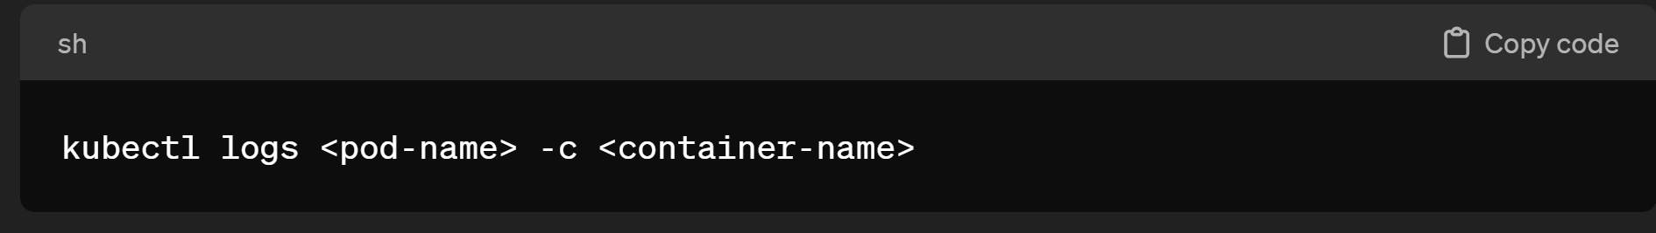

### Performance metrics

